1. The Server Manager windows showing the local computer properties

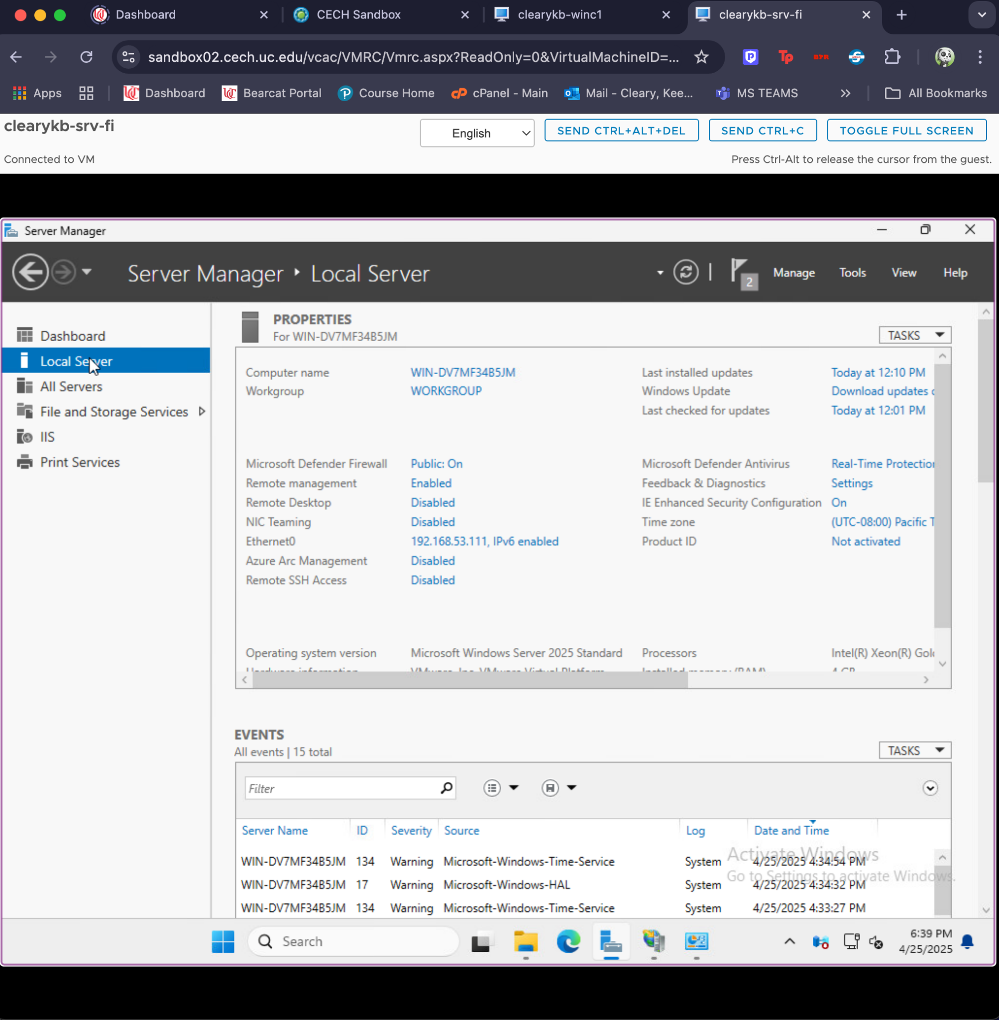

1. The list of user accounts in the Computer Management tool.

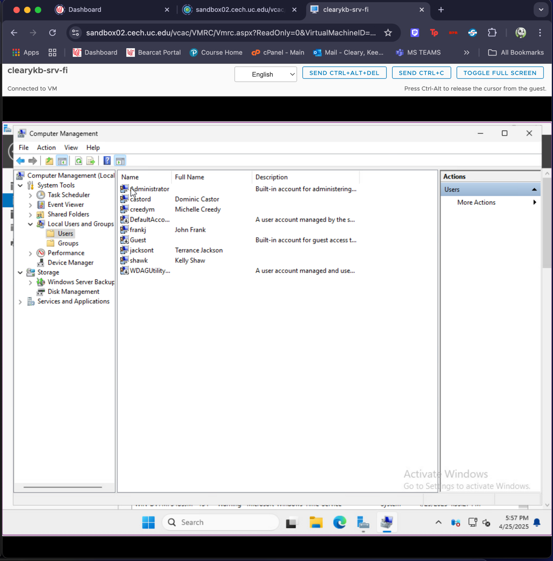

1. The properties window of the Web Dev group showing the members tab.

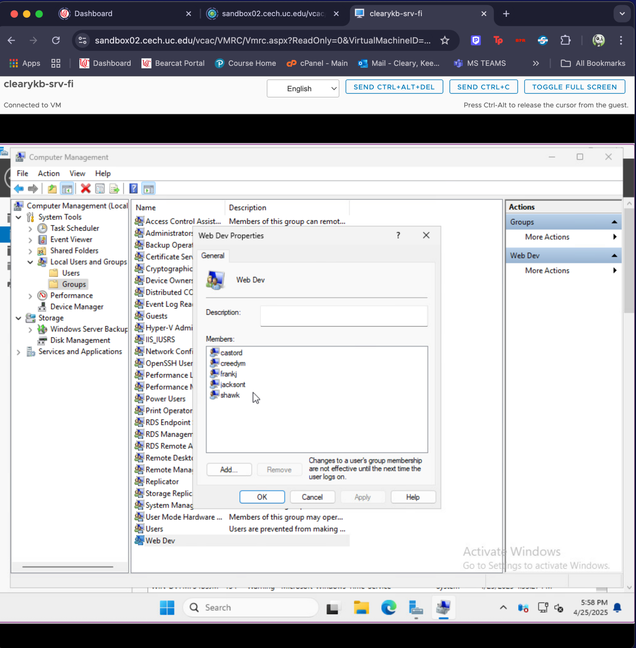

1. The NTFS and permissions of the shared web directory folder.

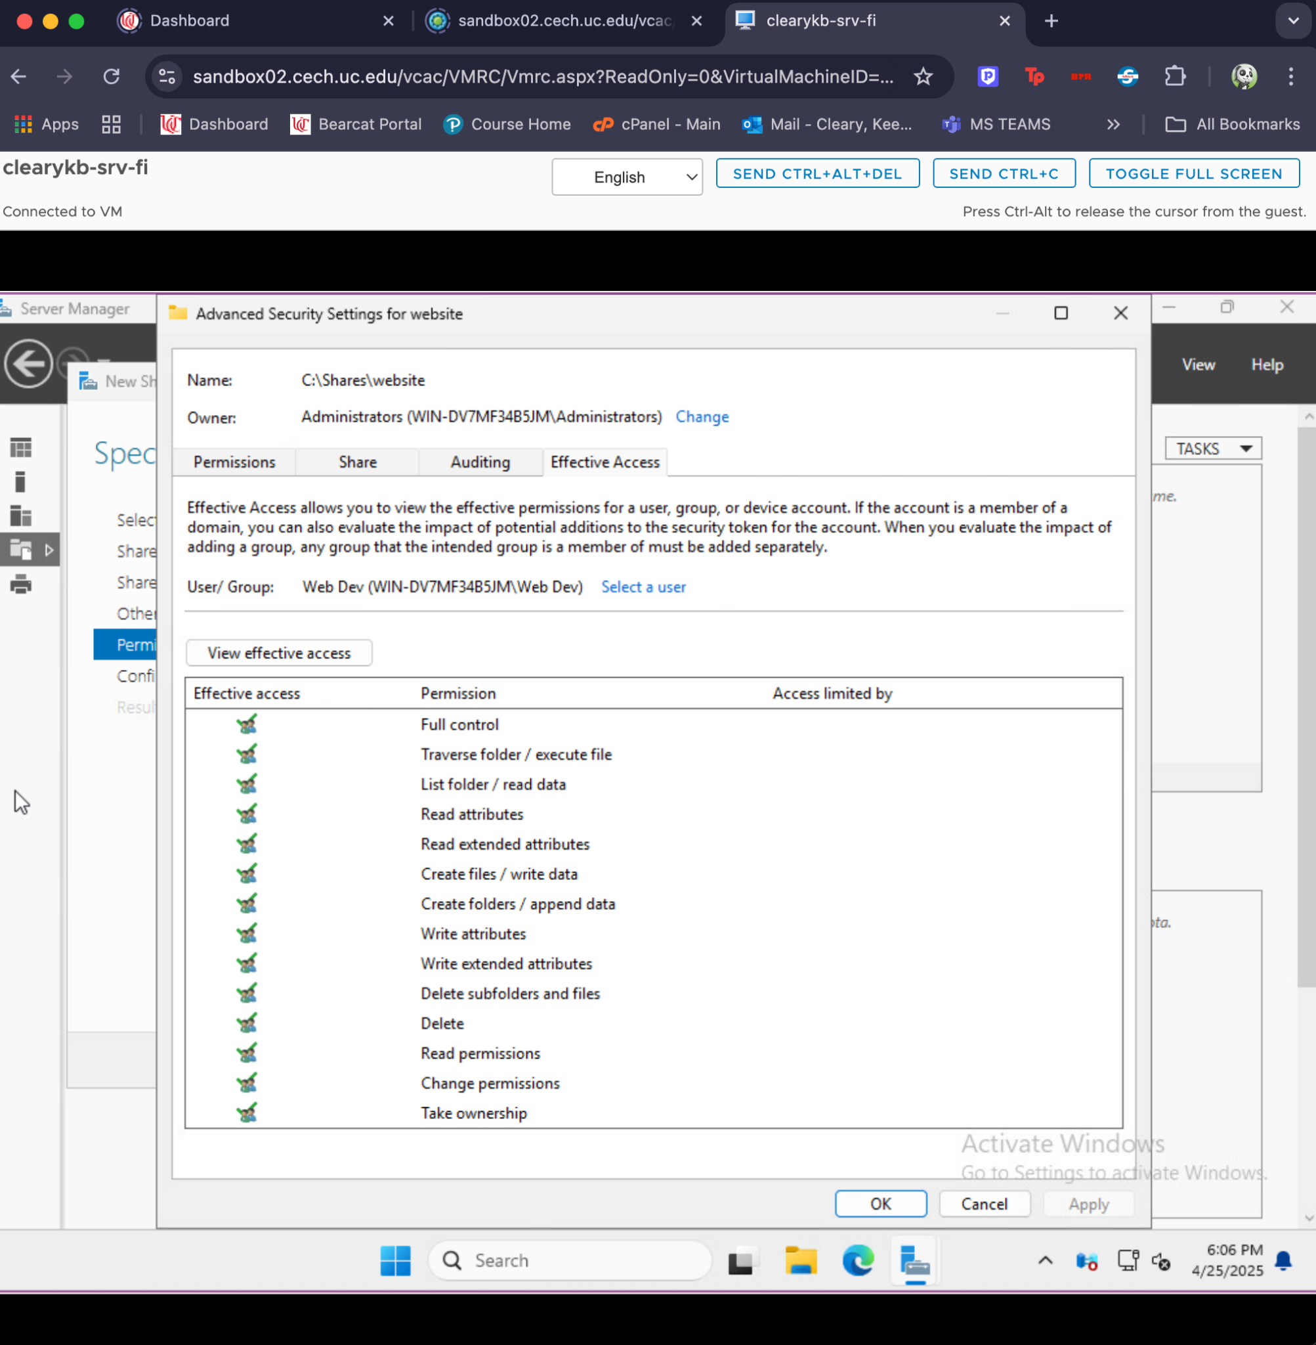

1. The Share permissions of the shared web directory folder.

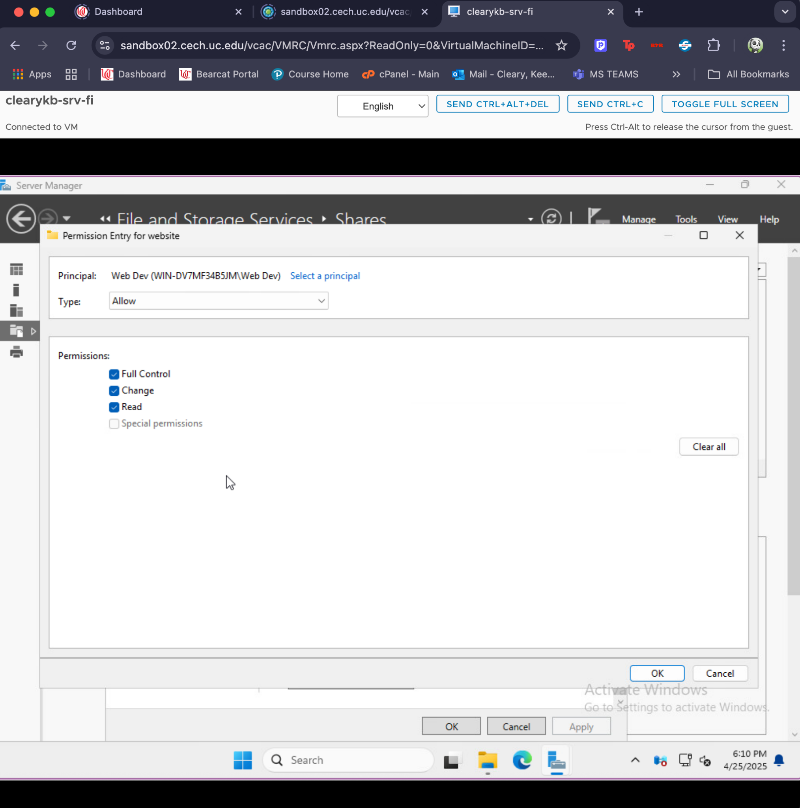

1. The shared folder shown through Windows Server Manager.

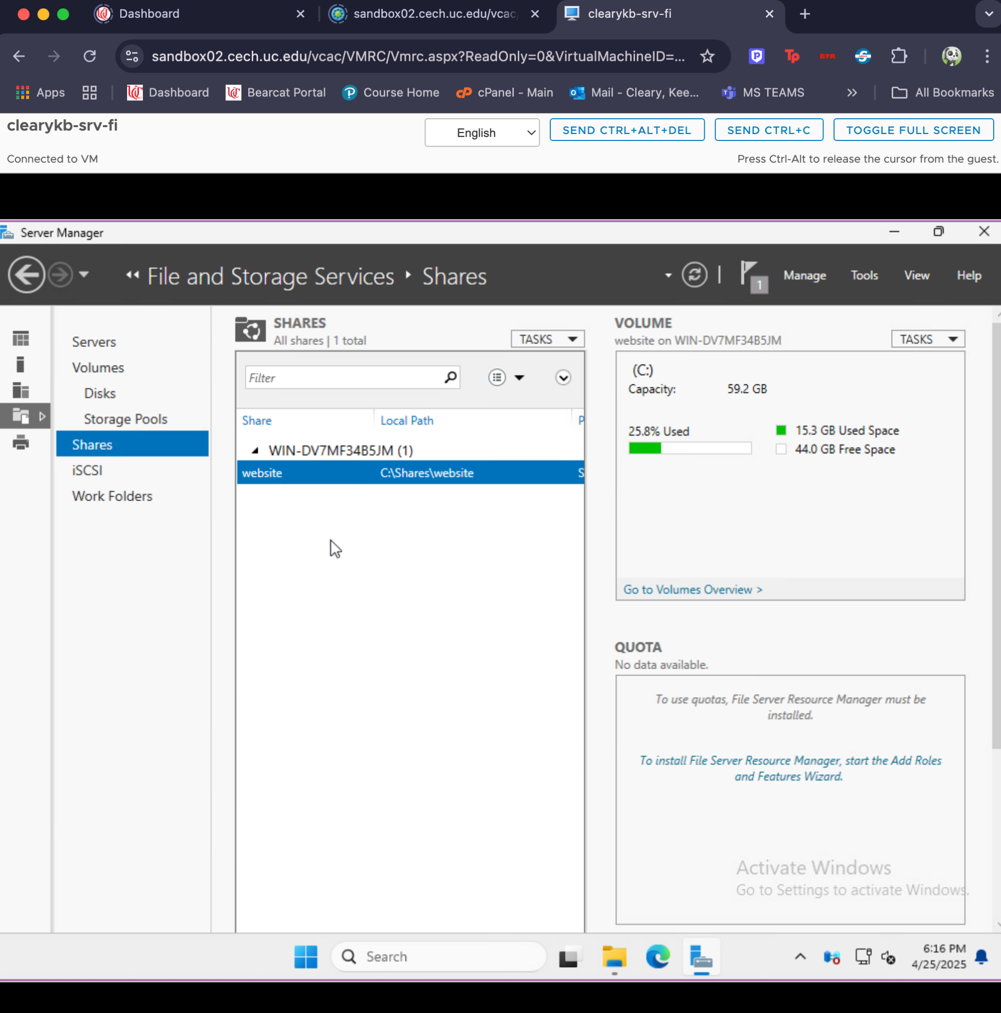

1. The basic settings for the IIS Web server.

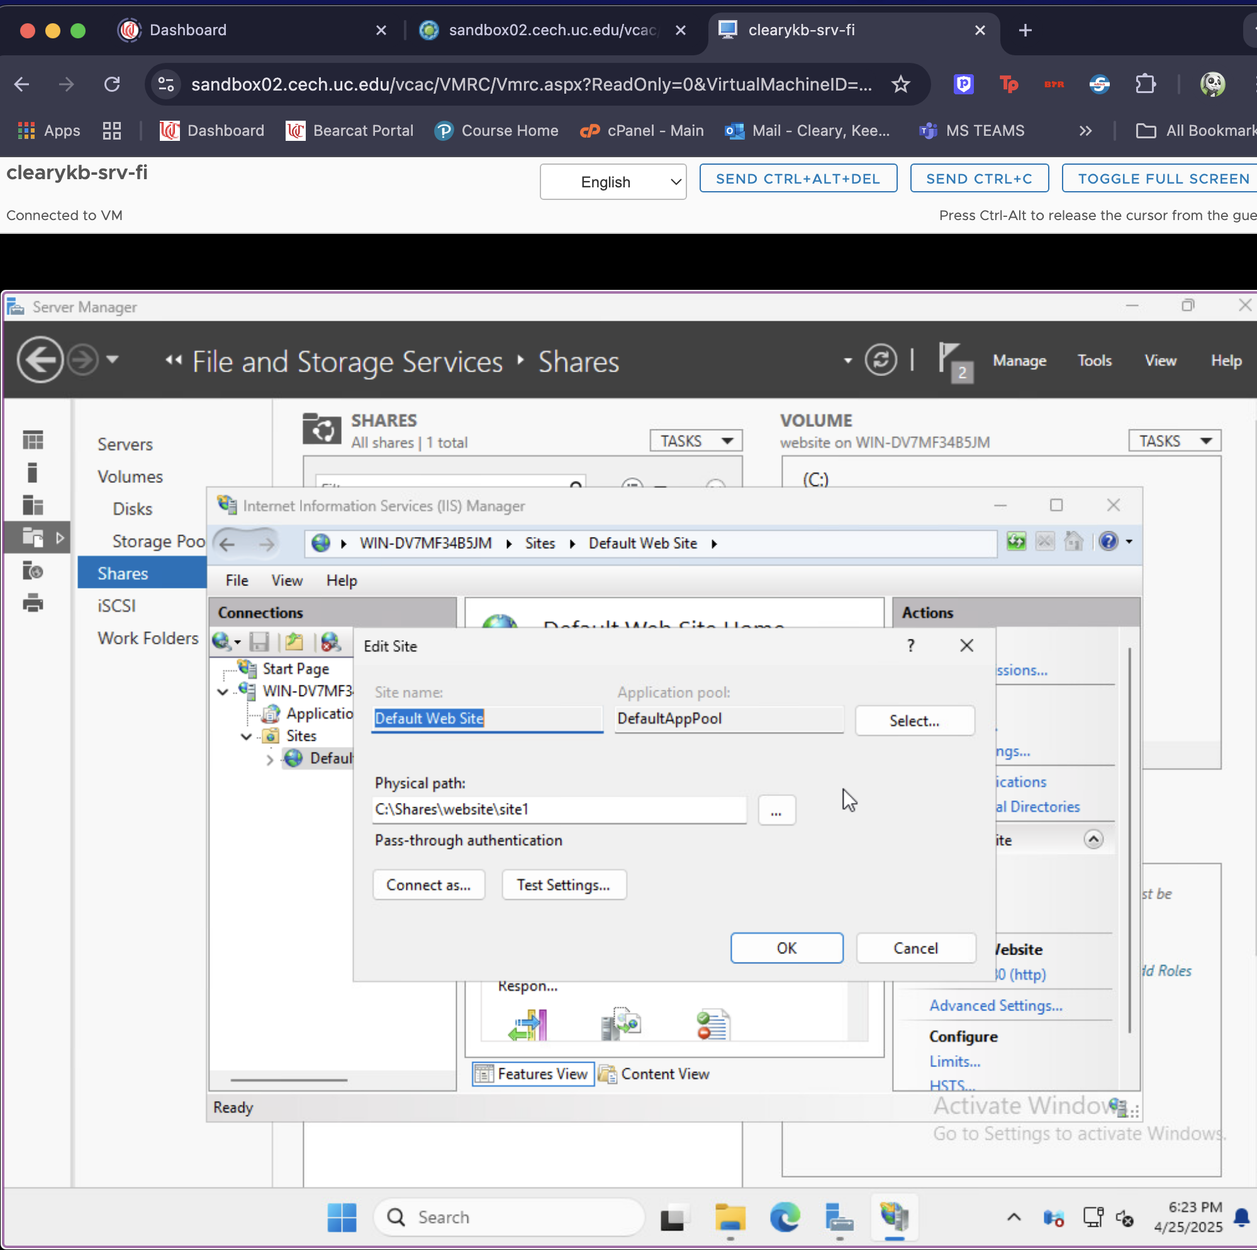

1. Allowed programs list for Windows Firewall.

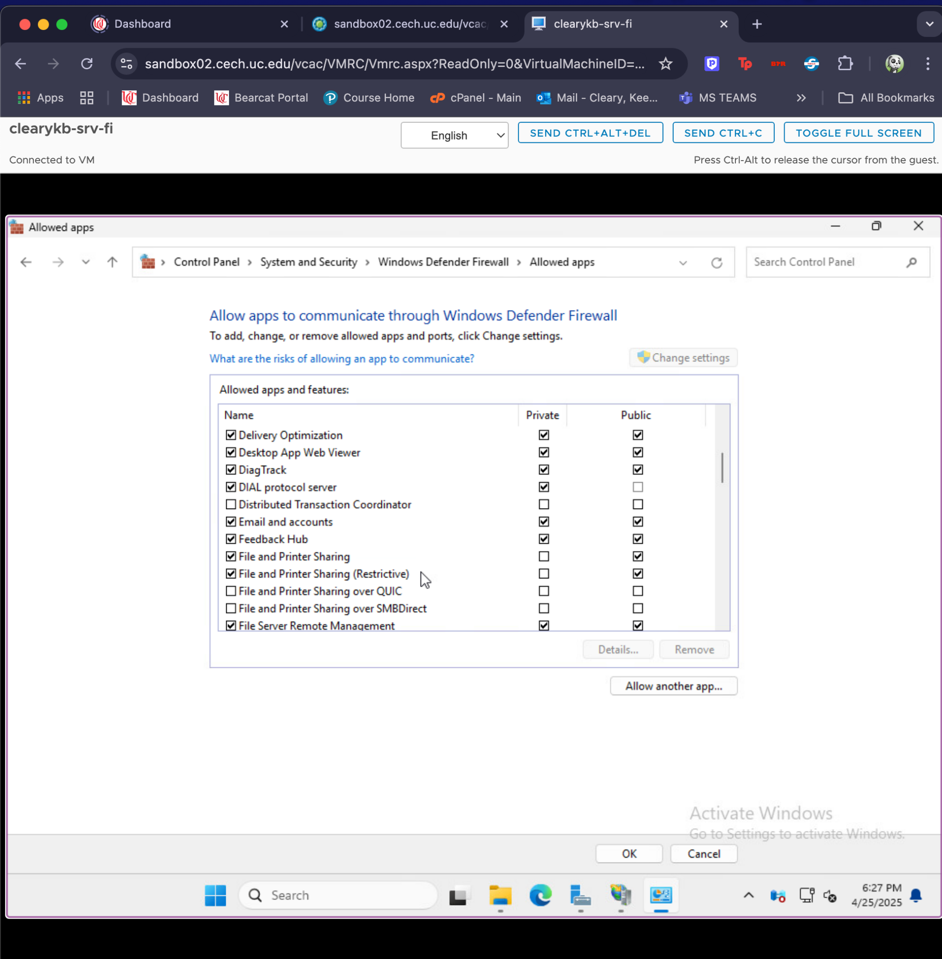

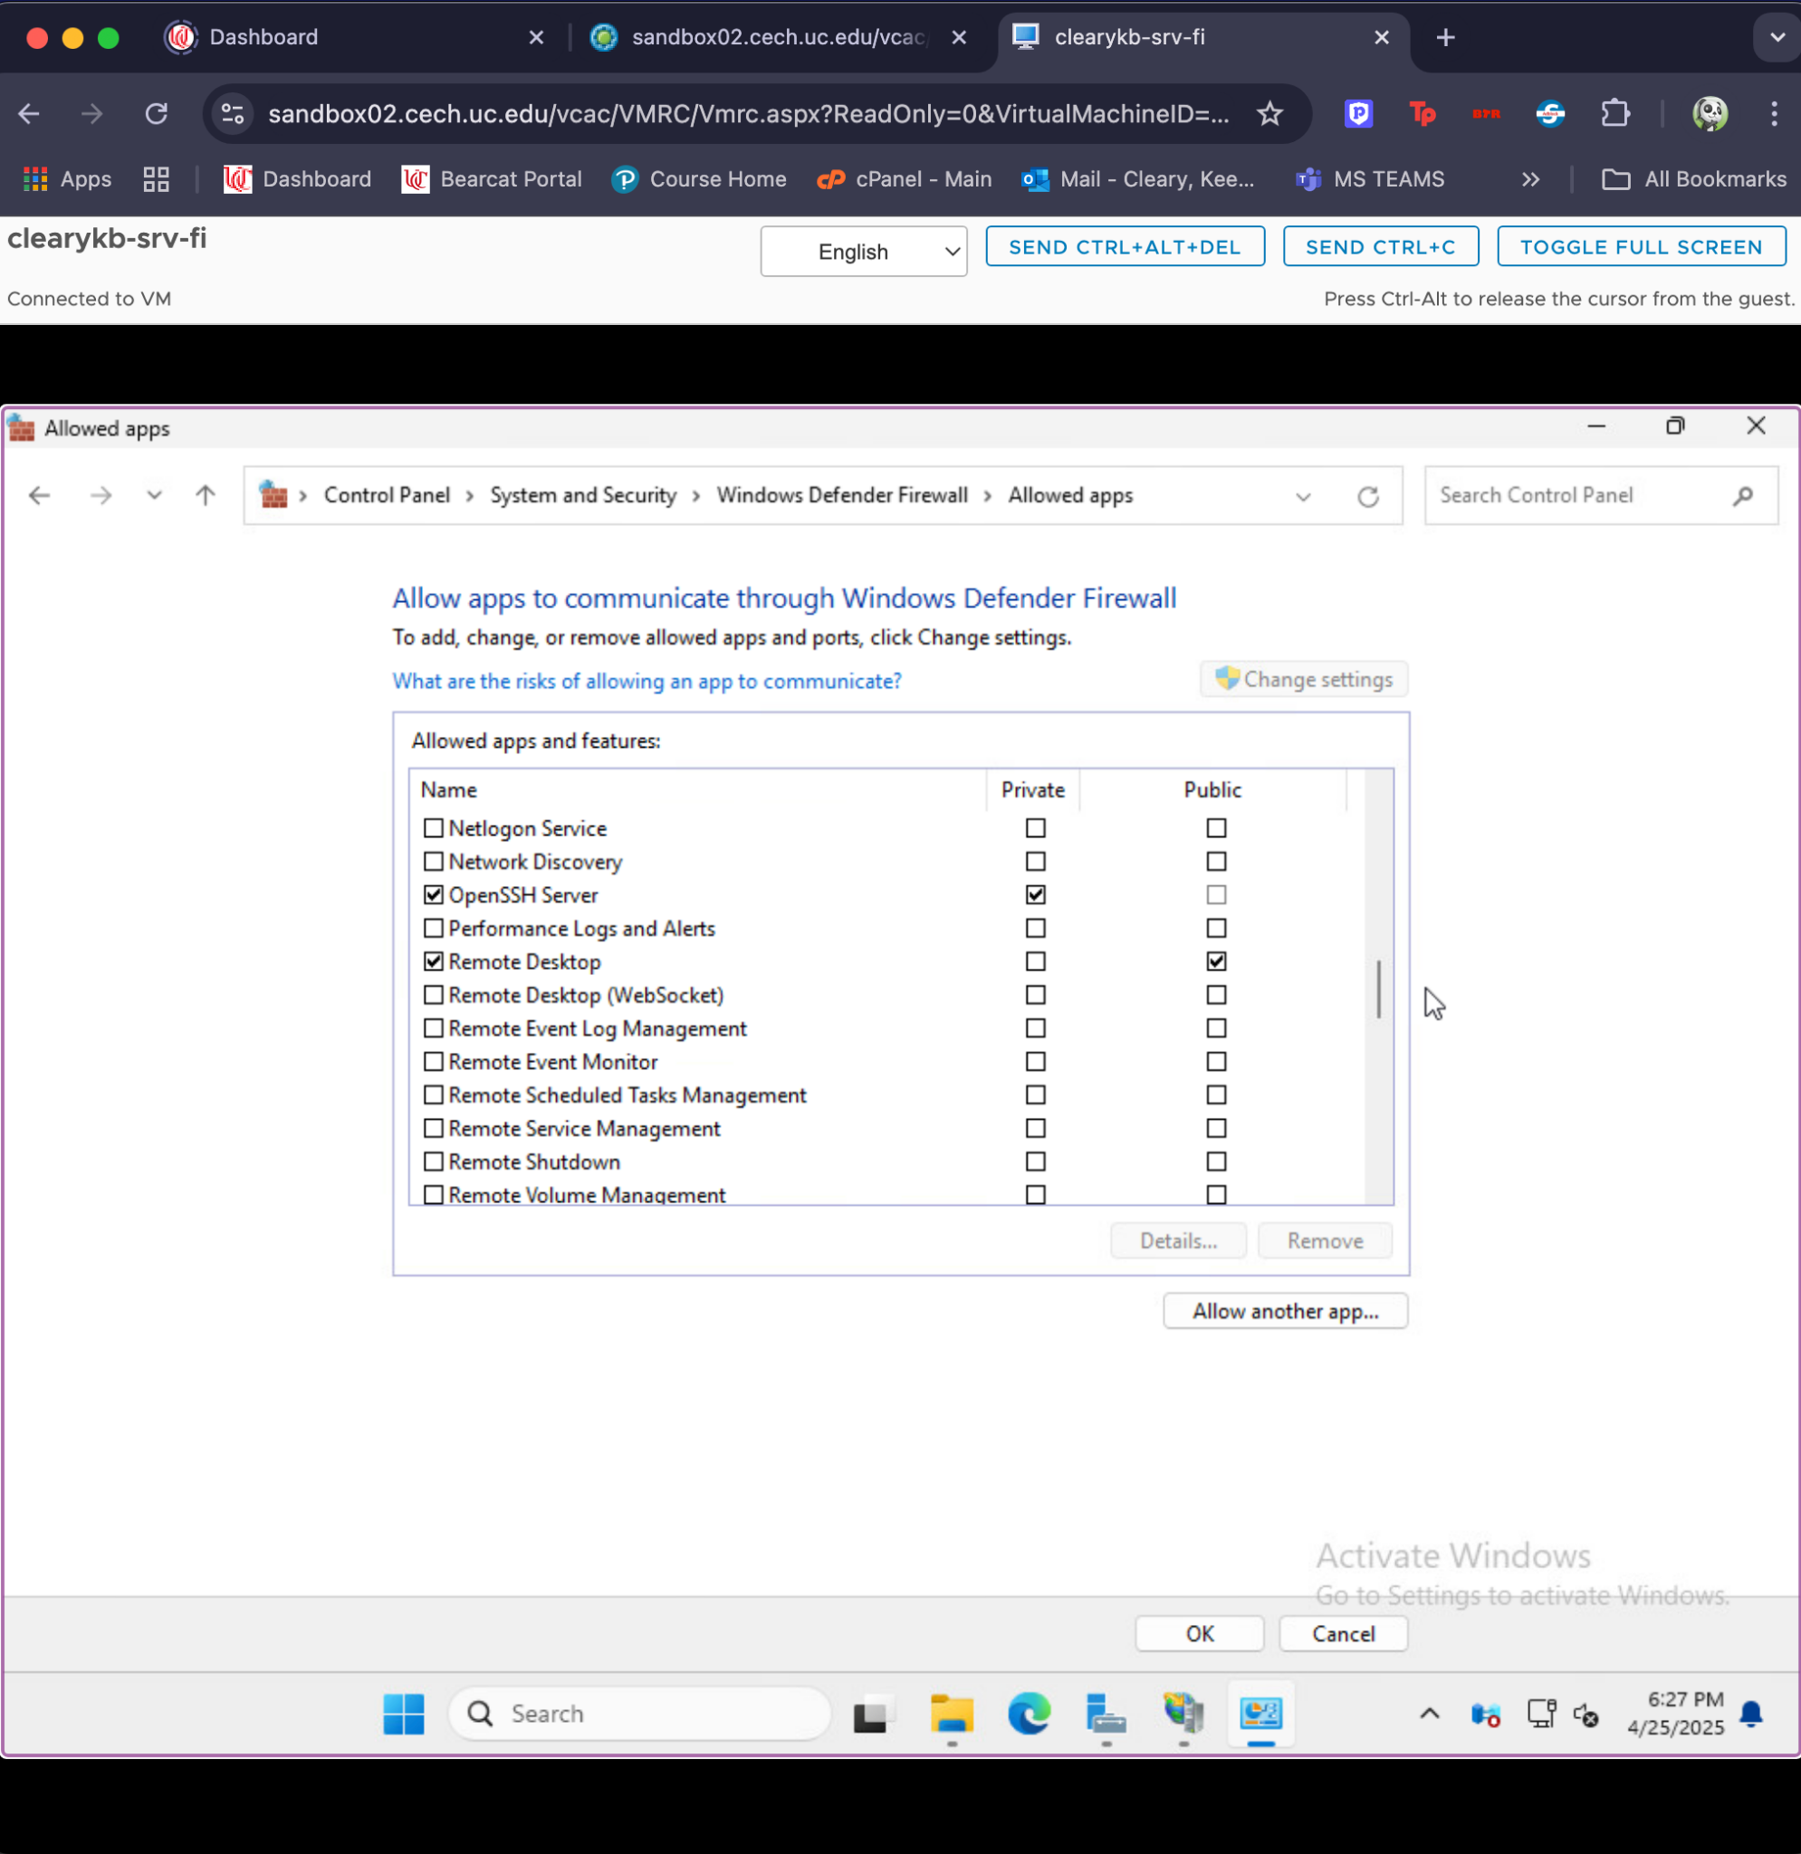

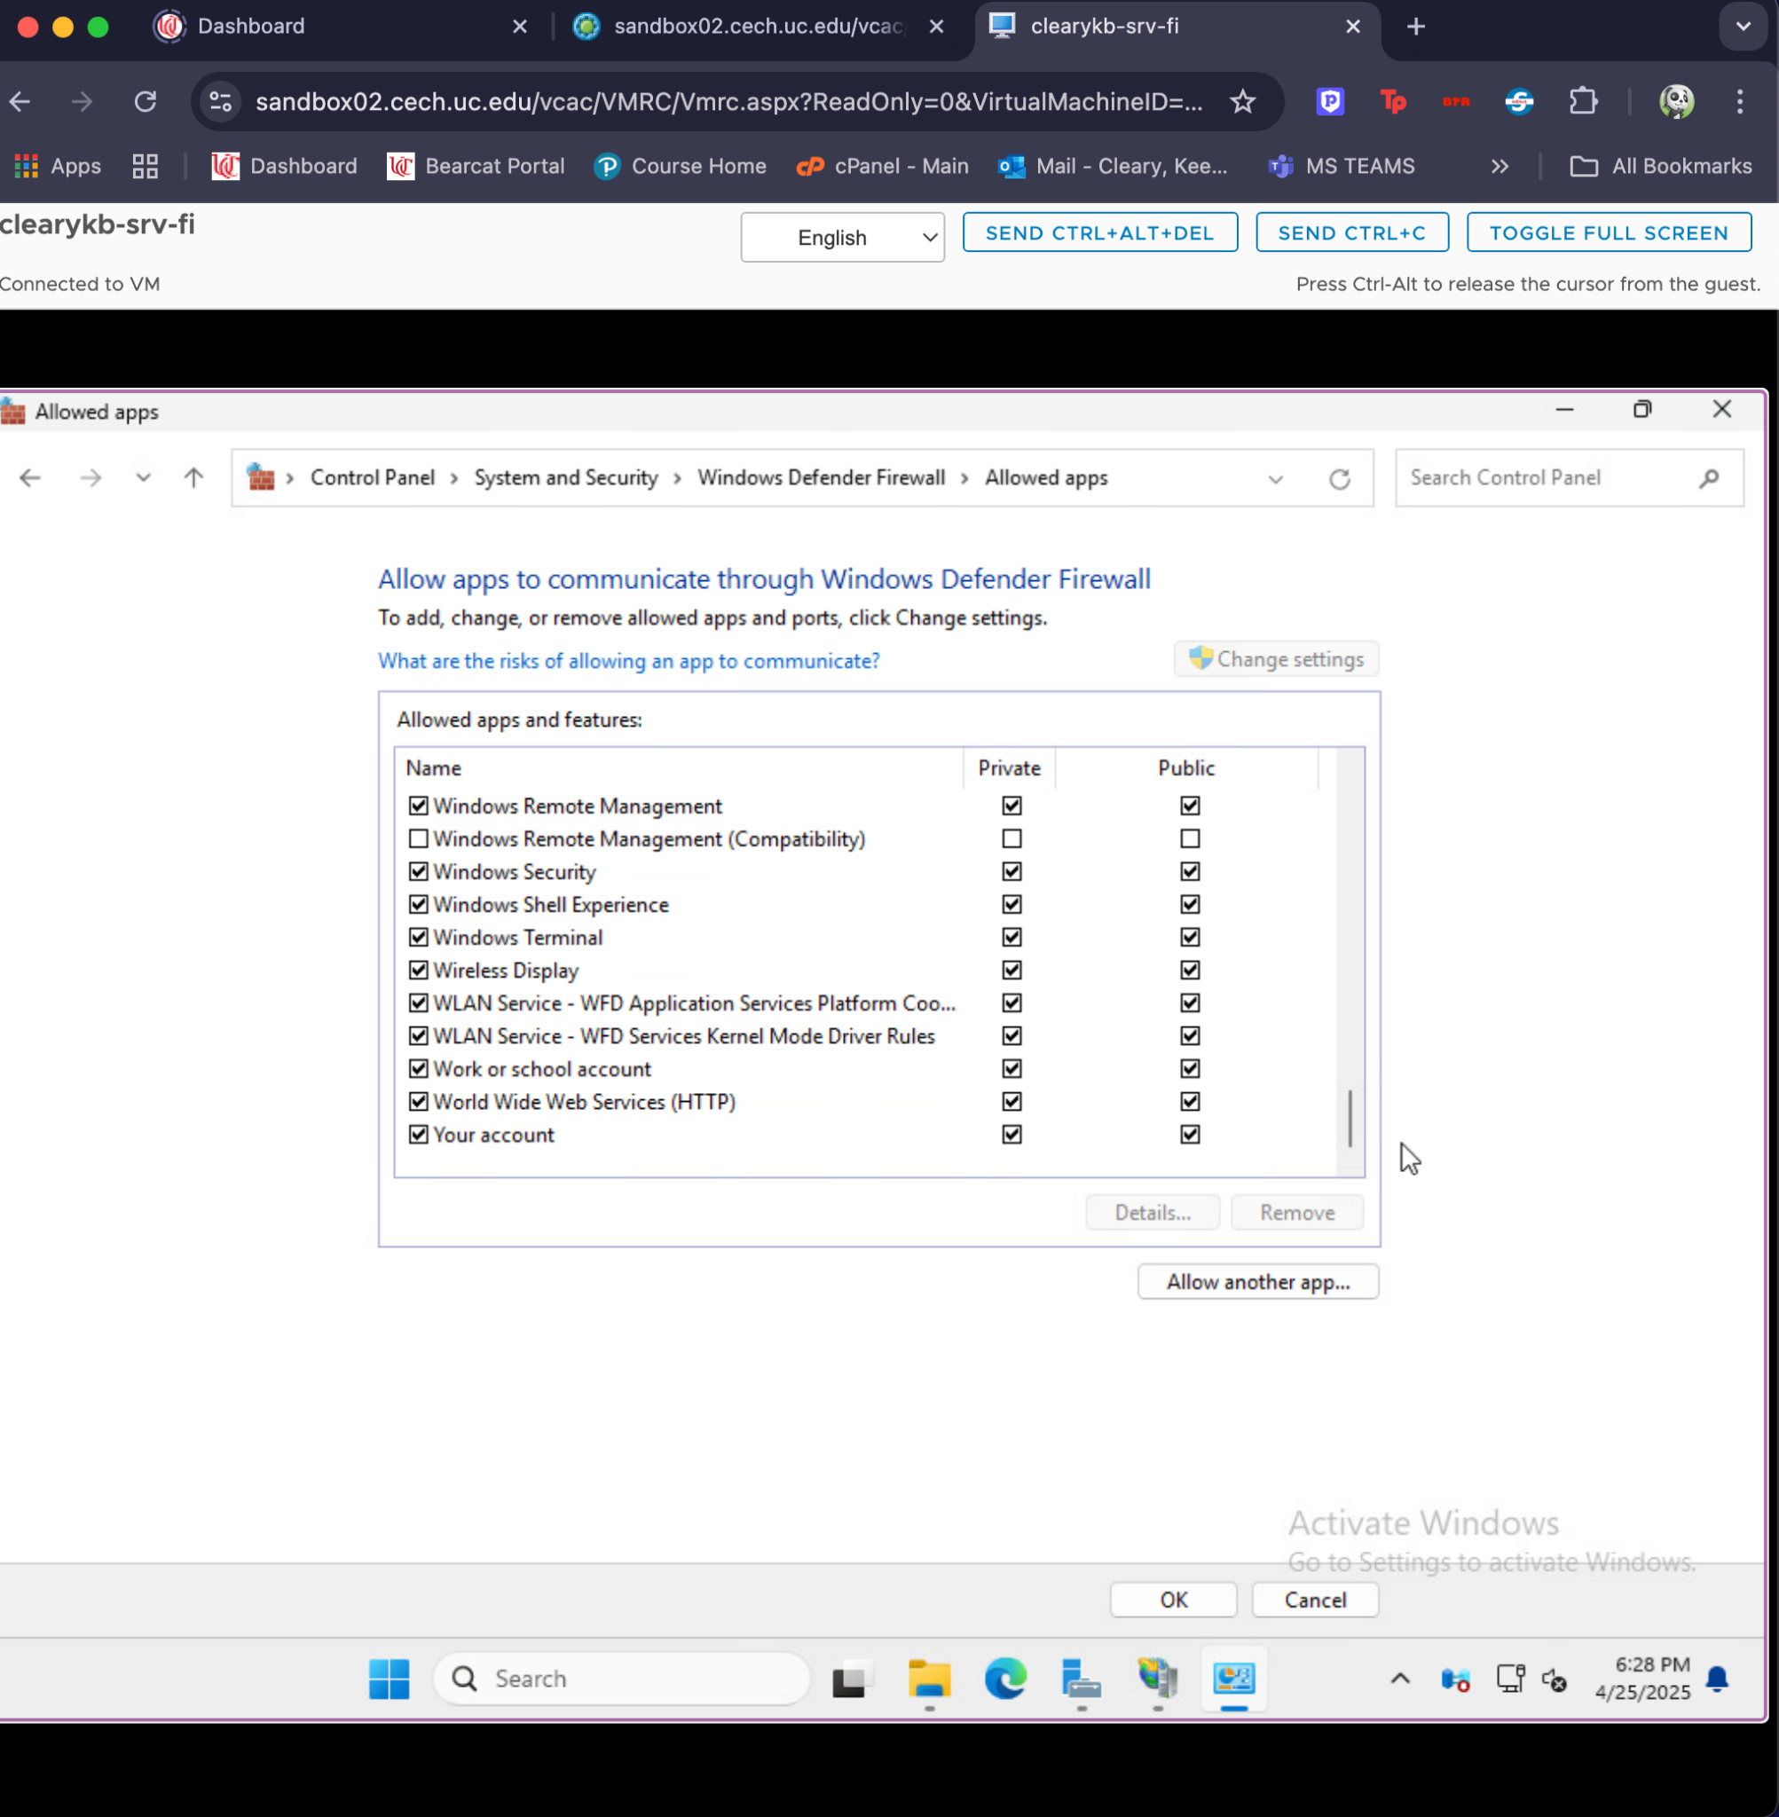

1. Connecting to the system from a Windows 11 workstation to access the shared directory.

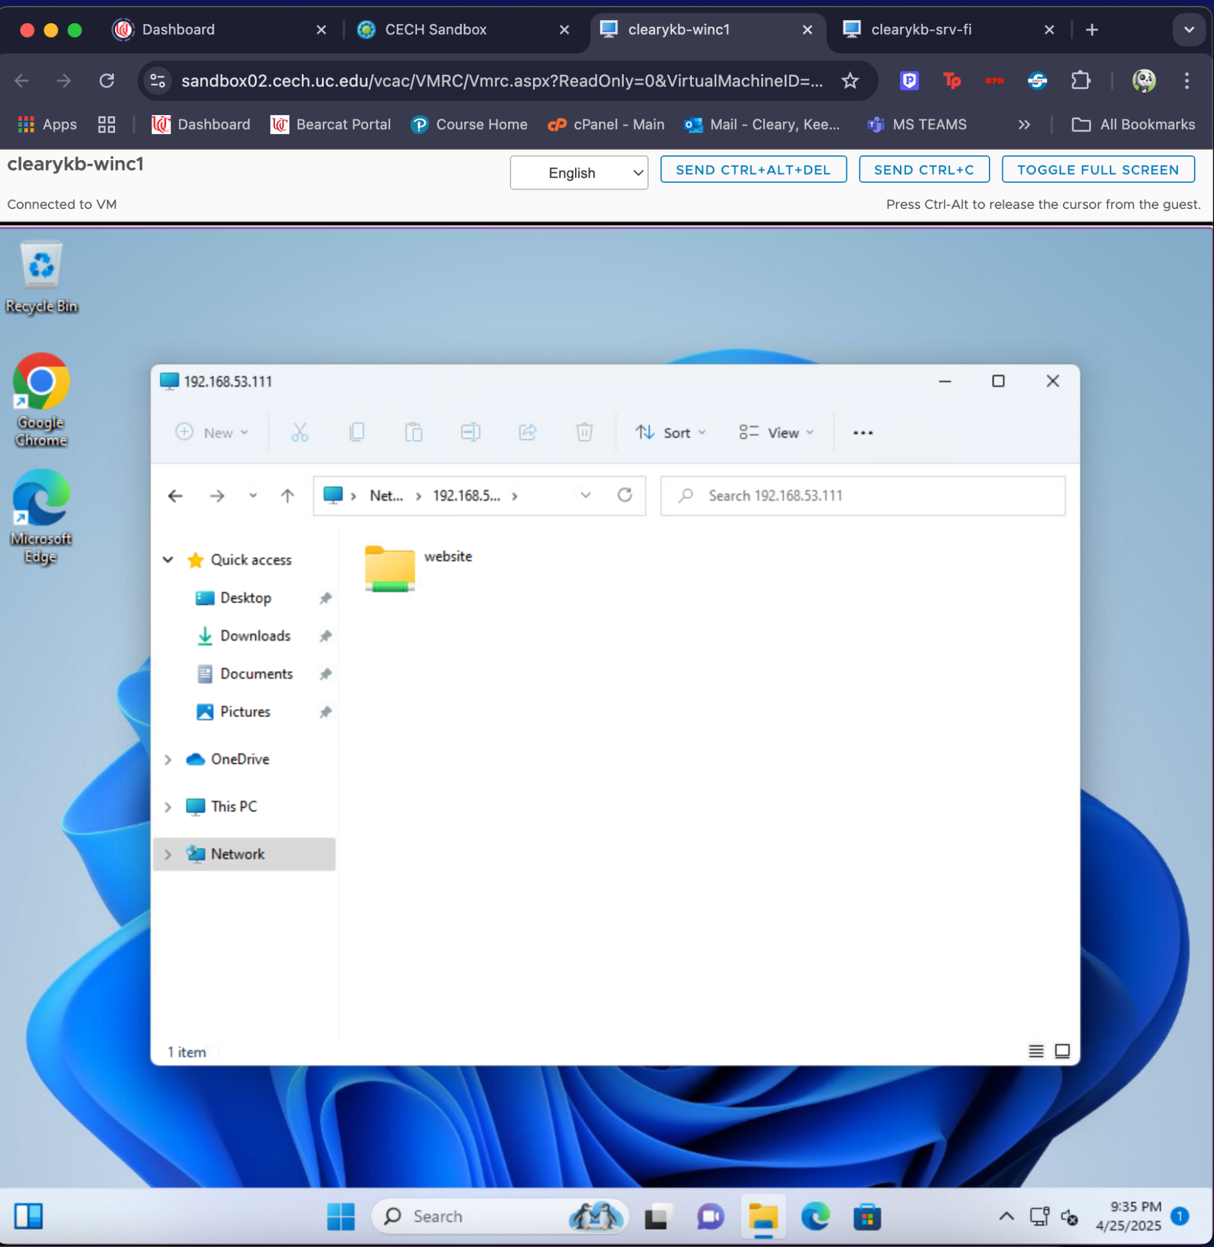

1. Connecting to the system from a Windows 11 workstation through a web browser using http.

